AUTONOMOUS CAR RACING WITH DEEP REINFORCEMENT LEARNING
TEAM INFORMATION (GROUP -7):
Sonal Prasad - 017475432, Anoushka Sawant - 015154074, Sravani Neelapala - 016801486
DATA SOURCES: Gymnasium, Stable-Baselines
We are considering two environments– a built-in 2D and a 3D external environment:
The 2D car racing environment is part of the Box2D environments. It’s a top-down racing environment, with a random track in every episode. In continuous, there are three actions, and in discrete there are five actions. The observation has a top-down 96x96 RGB image of the car and race track.
https://gymnasium.farama.org/environments/box2d/car_racing
The 3D car racing environment uses Pybullet to simulate real-world physics. It includes observations such as pose, velocity, and rgb-camera, which are obtained by sensors. Similar to the 2D environment, it also has three actions in the continuous space. Vehicle and track configuration are customizable and multi-agent racing is possible with PettingZoo API.
https://github.com/axelbr/racecar_gym/
Baselines : Stable-Baselines (Pytorch) - SAC, PPO, DDQN
Google Drive Link: CMPE 260 Project
ABSTRACT:
Simple autonomous driving is a useful application of reinforcement learning. In our project, we will focus on autonomously navigating a race track. Potential actions include accelerating, breaking, and turning left and right. Rewards are granted based on proximity to the finish line. Our approach will involve benchmarking D-DQN (Double Deep Q Network) with PPO (Proximity Policy Optimization) and LSTM + SAC (Long Short Term Memory with Soft Actor Critic).
LITERATURE SURVEY:
We focus on model-free deep RL for driving: continuous-control methods like SAC and PPO, and discrete methods like DDQN. We also investigate how discretizing actions versus using continuous control affects stability and sample efficiency, and how robust agents should be to randomized tracks and seed variance in CarRacing-style benchmarks.
Yuwono, F. et. al, highlight advantages of DQN which include handling large state space with images. The online network learns from the target network in a stable way. The experience replay buffer helps reduce the correlation between consecutive samples. The researchers found that DQN performed well in the CarRacing environment as it has a robust foundation. They also implemented PPO and found that
DATA EXPLORATION FOR 2D:
Box2D
We initialized and explored the “Box2D” environment from Gymnasium that simulates car racing based on physics. We experimented across continuous and discrete modes. We also adjusted the seed number for the environment which affects the randomization. The Google Collaboratory notebook below illustrates how the rewards change for 4 different combinations of modes and seed values. In both continuous and discrete environments, having a seed value of 42 led to higher returns (rewards) compared to the seed value of 0. We will be moving forward with the continuous mode.

The Google Drive folder contains videos of the car racing in 4 different modes. Additionally, it includes plots that are provided in the Google Colab.

Google Colab:
Exploring the Data.ipynb

Google Drive folder (CarRacing2D):
CarRacing2D

Box 3D (External environment)

We tried to get the 3D autonomous car racing simulation environment using the racecar_gym package, which is implemented on top of PyBullet and Gymnasium for simulating real car racing physics. We wanted to have an environment where we can then train reinforcement learning models for autonomous driving. We cloned the GitHub repository mentioned above in data sources for 3D and installed it by following the instructions, but we faced some technical issues in setting it up. The majority of the problems were because of version conflicts. Google Colab uses more recent versions of Python and NumPy that didn't align with the previous versions racecar_gym required and when tried locally faced similar challenges with dependency issues. Because of this, the environment could not be installed correctly, and we often ran into missing modules or dependency errors, especially for Gymnasium. We tried a number of solutions like reinstalling some versions, un-installing libraries with conflicts. While we weren't fully able to run the 3D environment by this time, we learned about how dependencies work together in complex environments.

Link for experimentation code: RacecarGym_3D_Setup.ipynb

Link for experimentation code: :3D_Experimentation.ipynb

RL ALGORITHMS
We implemented three RL algorithms for autonomous car racing: DDQN, SAC, and PPO using Stable-baselines. All methods were trained and tested on the Gymnasium CarRacing-v3 and we reported benchmark results, including learning curves between average returns and time steps, and short videos of representative runs.

SAC Smoke test: SAC with a CNN policy is up and running: a smoke test was performed at 20k steps. Next, we'll train SAC much longer (about 1-3 million steps) and save the best model along the way. For DDQN, we'll use a different set of discrete actions (a grid of steer and throttle options) with finer controls and evaluate on the same seeds. We trained SAC on CarRacing-v3 for only ~20k steps with 4 parallel environments and 4-frame stacking, then ran deterministic evaluations with a cap of 3000 steps. (The environment itself times out around 1000). Across five test seeds, every run hit the 1000-step time limit. This is normal for such a short training run and shows the pipeline works. We saved a short video-one episode-and a simple bar chart of rewards to our shared folder.

Colab Link : https://colab.research.google.com/drive/1L6fDZZgxpz3yptoyTeYaajuWkbQZfIWN

Smoke test results:

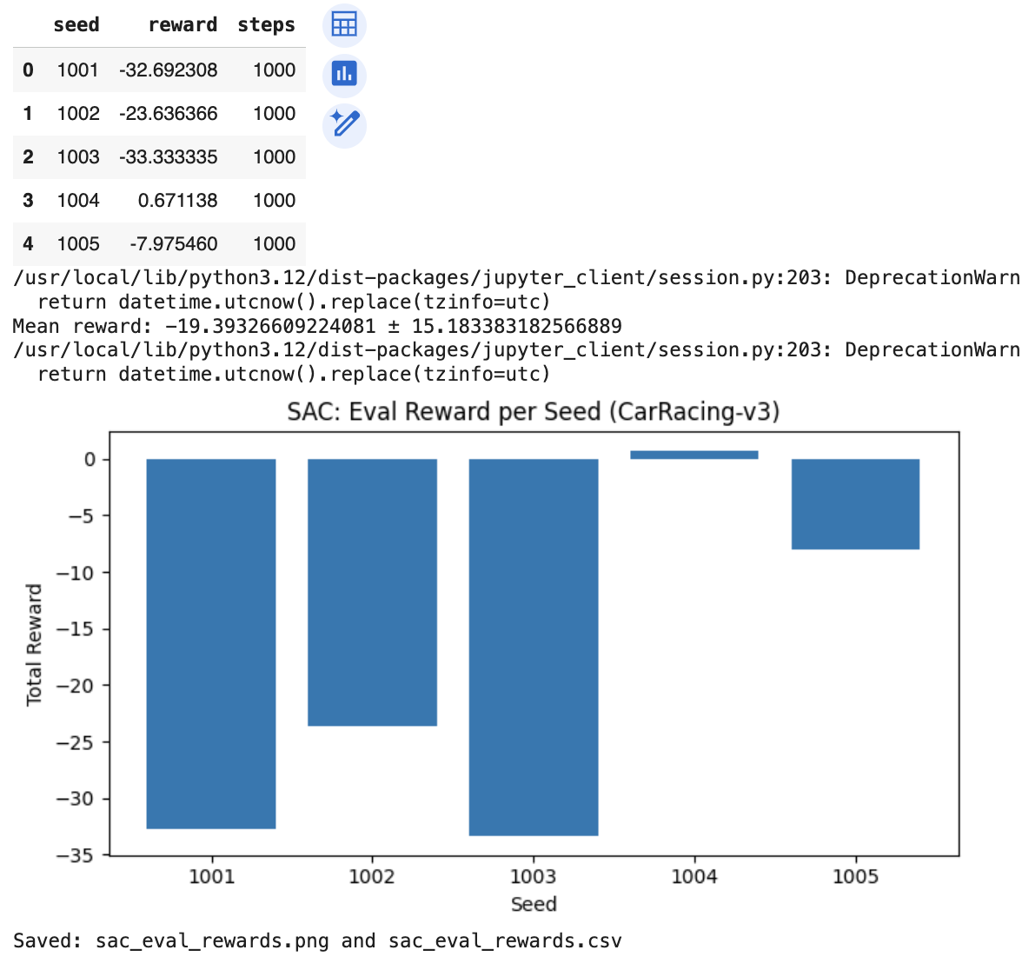

DDQN

We implemented DDQN because it is superior to DQN. Standard DQN tends to overestimate Q-values due to using the same network for both action selection and action evaluation. This leads to unstable learning in environments with high-variance rewards and rich visual observations— both of which characterize CarRacing-v3. To mitigate this, the project implemented Double DQN, which introduces a second, slowly updated “target” network to decouple action selection from action evaluation.

We enabled the built-in discrete action mode, where the environment internally maps a small set of discrete actions (e.g., steer left, steer right, accelerate, brake) to their continuous counterparts.This modification preserves the continuous physics dynamics of CarRacing while making the action space compatible with the DDQN architecture, which estimates Q-values for a finite set of actions.

We override the training from the DQN class to include a replay buffer, an online network and a target network, current Q-value estimate, Huber loss, and a target network update. A Convolutional Neural Network (CNN) policy was used to process the raw 96×96×3 96×96×3 RGB frames from CarRacing-v3. This architecture is appropriate for visual control tasks and is provided through Stable-Baselines3’s CnnPolicy. The fully connected branches of the network used: 2 hidden layers of size 256 units each, ReLU activation, and Adam optimizer with a learning rate of 10⁻⁴.

The hyperparameters were: gamma = 0.99, buffer_size = 100,000, batch_size = 32, learning_starts = 10,000, exploration_fraction = 0.2, exploration_final_eps = 0.07, train_freq = 16, gradient_steps = 8. This training schedule performs eight gradient updates every 16 environment steps, providing a balance between sample efficiency and computational load. We show the results in the following experiments of 25k, 1 million, and 600k time steps.

Time Steps: 25k

At 25,000 time steps, the following were the rewards per timestep. Over 10 episodes, the mean reward was -5.90 ± 38.16. The mean episode reward fluctuated between -130 and +20. There is high variance in the rewards, and there are occasional spikes. The model has not started meaningful learning.

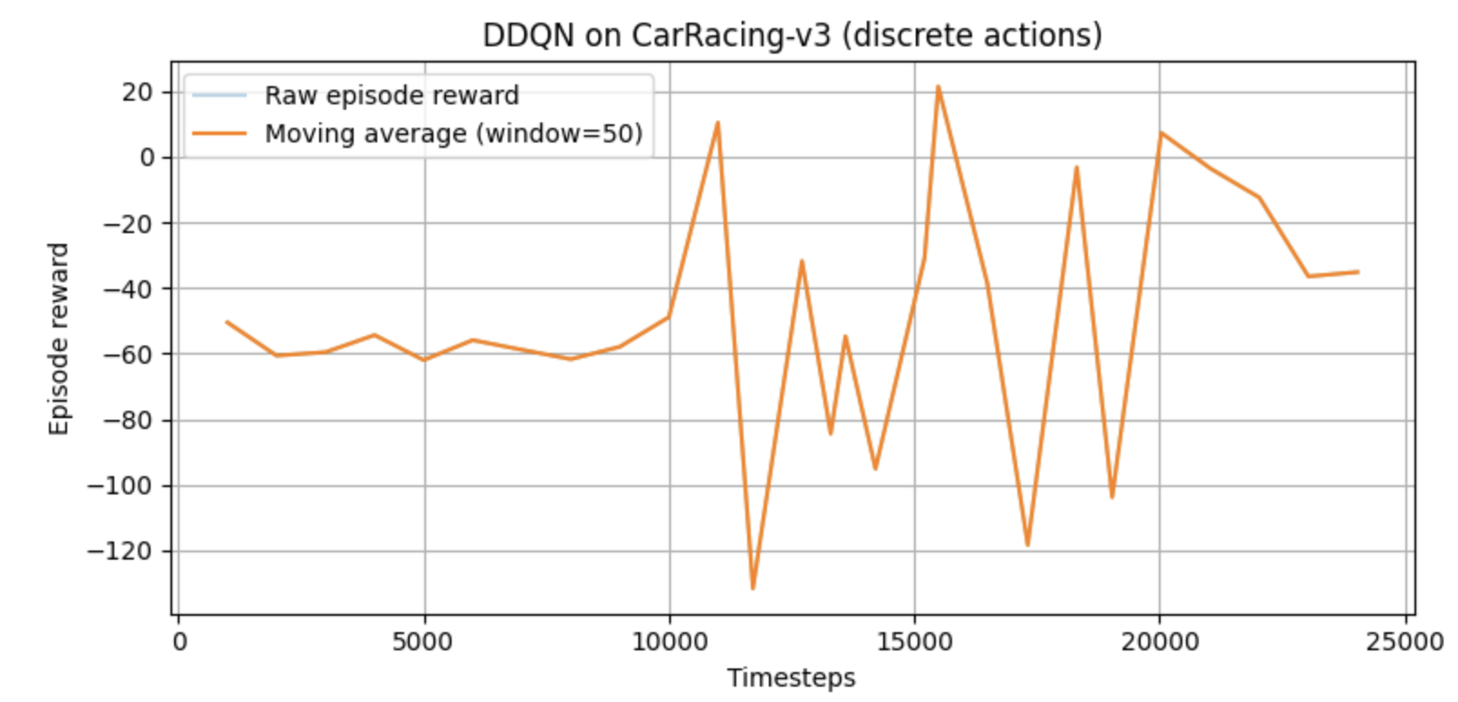
At 25,000 time steps, the following were the returns for each episode. Many episodes had negative returns. None of the episodes showed stable driving. The car was mostly at an exploratory stage and hadn’t experienced high rewards. The model underfit with erroneous behavior.

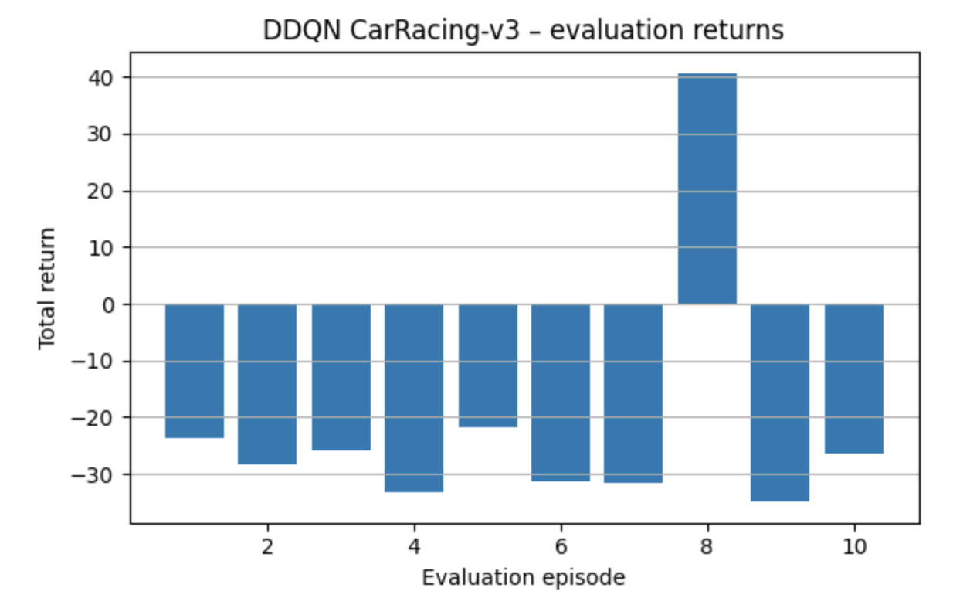
The following video shows how the racecar drives when trained at 25,000 steps:
https://drive.google.com/file/d/1kfpV--ZYeYxQdBuRpKaQmhY8Oi9bbZBO/view?usp=drive_link

Time Steps: 1 Million

At 1 million time steps, the following were the rewards per timestep. We can see that the model converges somewhere between 600k - 700k time steps. In the first 300k steps, the rewards are near 0 or are negative. Around 300k - 450k time steps, the agent learns important driving techniques, such as maintaining speed, staying on the track, steering, not lingering in the grass (off-track). At around 450k - 650k, the agent had the highest stability, and the moving average reward peaks. At 650k timesteps and greater, the mean reward slowly decreases, variance increases, and the training becomes noisier.

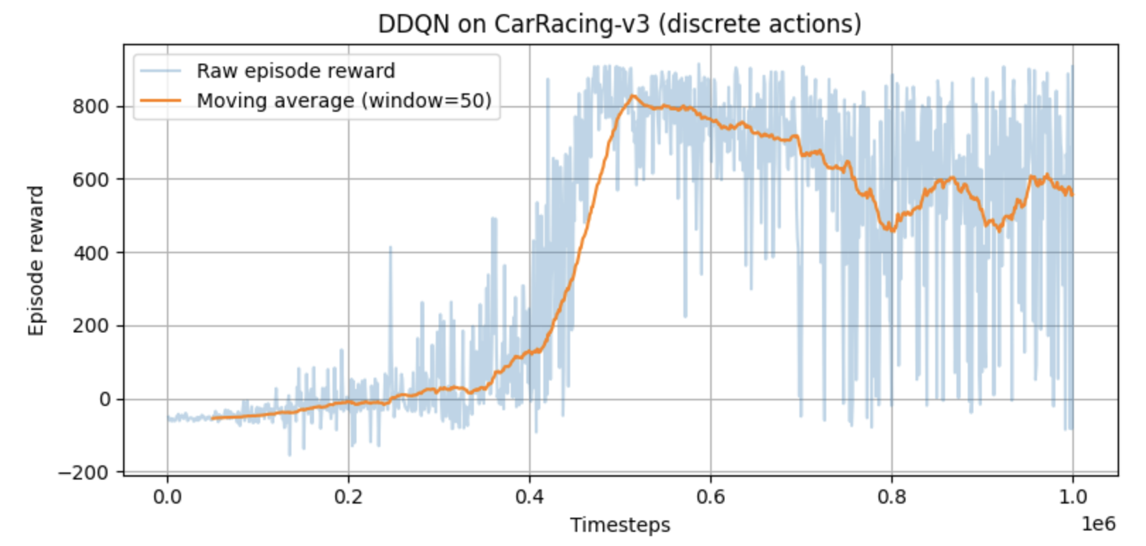

At 1 million time steps, the following were the returns for each episode. Most of the episodes achieve high returns between 520 to 700. Only one episode performed poorly. There was some variability due to having negative returns in one episode. 9 out of 10 episodes showed strong driving. The episodes that achieved 500 or higher rewards had stable driving. A reward of 700 is very good. However, the policy is not fully stable since there is some instability with one episode having negative rewards.

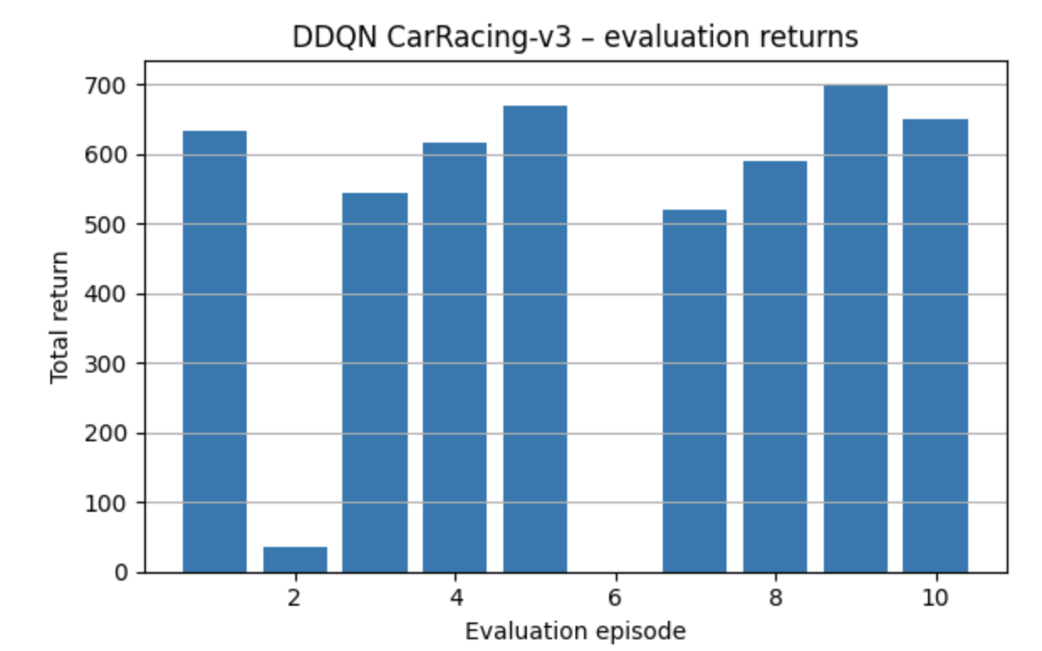

The following video shows how the racecar drives when trained at 1 million steps:
https://drive.google.com/file/d/1qSuZ8zXigcoHw7S2f-qMRvYXs4zQTHIZ/view?usp=drive_link

Time Steps: 600k

At 600,000 time steps, the following were the rewards per timestep. The rewards reach around 800 points at 600,000 time steps. Over 10 episodes, the mean reward is 809.85 ± 147.64. From 0 - 300k time steps, the reward ranged from 0 to -50. There was high noise and inconsistency. At this stage there was random exploration. From 300k - 400k time steps, there is a sharp and steady rise in the moving average. The agent is starting to learn competent driving behavior. From 400k - 600k time steps, the move average peaks around 850-900 rewards. This shows a stable policy, strong generalization to many track segments, and a replay buffer rich with successful experiences.

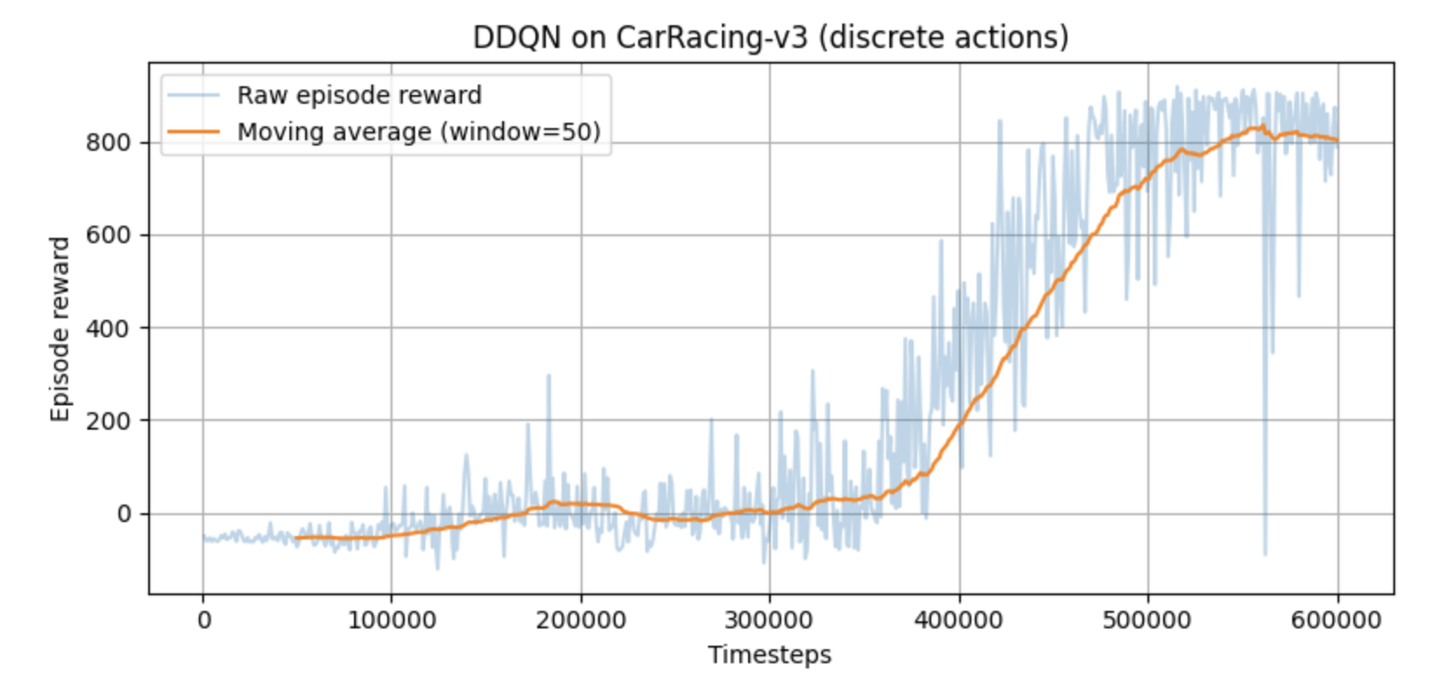

At 600k time steps, the following were the returns for each episode. In 7 out of 10 episodes, the total returns are above 800. A few episodes fall in the range of 450 - 550. Only one episode performs poorly, with around 250 rewards. Overall, the agent performs well.

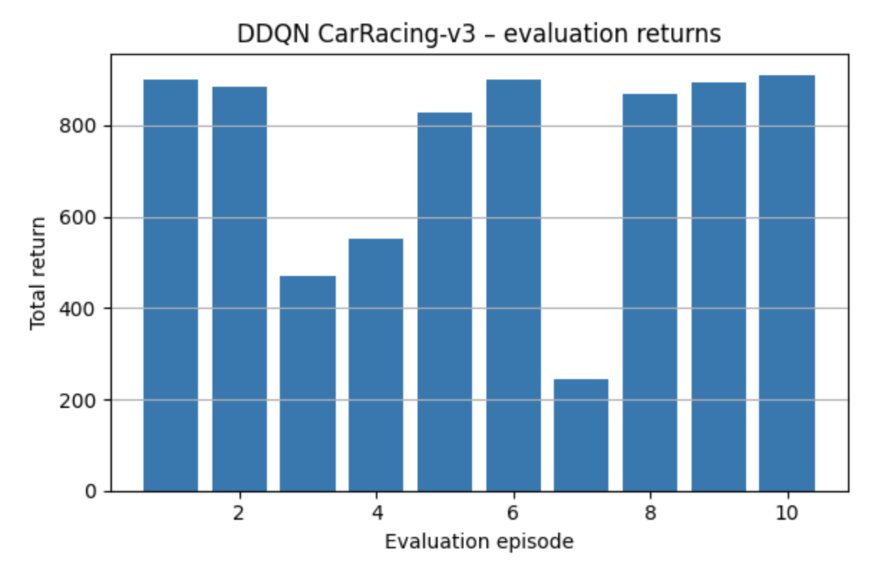

The following video shows how the racecar drives when trained at 600,000 steps:
https://drive.google.com/file/d/1vcCzmlOQdQLesd7R8Zr7Ttv1w6WTPe1u/view?usp=drive_link

SAC

SAC Smoke test: SAC with a CNN policy is up and running: a smoke test was performed at 20k steps. Next, we'll train SAC much longer (about 1-3 million steps) and save the best model along the way. For DDQN, we'll use a different set of discrete actions (a grid of steer and throttle options) with finer controls and evaluate on the same seeds. We trained SAC on CarRacing-v3 for only ~20k steps with 4 parallel environments and 4-frame stacking, then ran deterministic evaluations with a cap of 3000 steps. (The environment itself times out around 1000). Across five test seeds, every run hit the 1000-step time limit. This is normal for such a short training run and shows the pipeline works. We saved a short video-one episode-and a simple bar chart of rewards to our shared folder.

Colab Link : https://colab.research.google.com/drive/1L6fDZZgxpz3yptoyTeYaajuWkbQZfIWN

Smoke test on 20K:

We train a Soft Actor-Critic (SAC) agent on the Gymnasium CarRacing-v3 environment with a continuous action space: steering, throttle, and brake. The agent learns directly from pixels, which requires converting frames to 84×84 grayscale, stacking 4 consecutive frames for motion capture, and normalizing rewards during training for more stabilized learning. We use Stable-Baselines3 with a CNN-based policy and slightly larger feature extractor for image inputs, and all experiments were run on Google Colab with an A100 GPU. We follow a staged process in training: firstly, a small 20k-step smoke test to make sure the whole pipeline (data flow, logging, evaluation, and video export) works correctly; secondly, we tried a 1M-step run, but it became too slow and unstable over roughly 12 hours of training, so we stopped it and instead focused on a 500k-step run.
Because performance can improve and then later degrade in reinforcement learning, in this last 500k-step experiment we periodically evaluated the agent and saved the best checkpoint based on the evaluation performance. The best checkpoint reached an average reward of 682.02 ± 268.29 over multiple evaluation episodes; this means that the car can usually follow the track for long stretches but still shows high variability between episodes and tracks. Interestingly, the final model at the very end of training performed worse than this best checkpoint, reinforcing the need for model selection based on validation performance rather than just using the last weights. The total training time for this 500k-step run was 7 hours, 26 minutes, and 35 seconds on the Colab A100. Overall, SAC worked well for this continuous-control, pixel-based task, especially with frame stacking and reward normalization, but the results also highlight that pixel-based RL is sample-hungry and high-variance. With more time and resources, we would extend training to at least 1M steps, add early stopping when evaluation performance stops improving, and run multiple seeds in order to get a more reliable estimate of performance.

Experimentation includes: Experimented with 20k as smoke test, gave some results and proceeded with 1M didn’t work for 12 hrs and stopped, so switched to 500k, converged and got the graph.
Model type : SAC
Discrete: No
Average reward: 682.02 ± 268.29
Training Time: 7:26:35
Total training steps: 500k
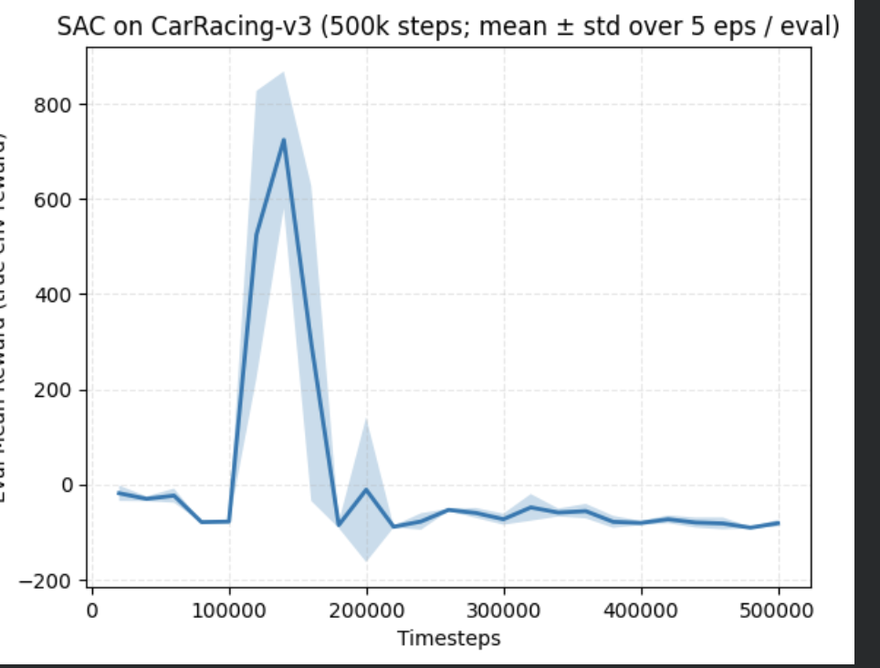
https://drive.google.com/drive/u/0/folders/1mjBbcDILNuhVLBodaazJ5ZBymi427Ond
PPO

When training our PPO agent, we also used a CNN-based policy. While we converted frames to grayscale, we did not stack consecutive frames to limit compute time. Training for one million steps took roughly five hours on an A-100 GPU. The mean reward for the best model was 797.90 +/- 199.38. Although the reward oscillates, it increases overall across the million timesteps. The results appear to have less variance near 800,000 time steps.

Model type : PPO
Discrete: No
Best model average reward: 797.90 +/- 199.38.
Training Time: 7:26:35
Total training steps: 1e6
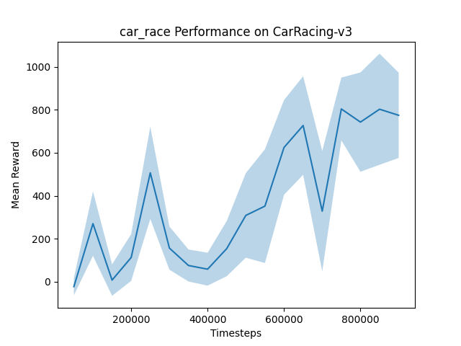
The video and code can be found here: PPO

CONCLUSION:
All three agents’ best models had comparable performance, which were close to 800. DDQN performed well given a discrete set of actions. For continuous actions, PPO proved to be the more stable algorithm, but it required more time steps to come to optimal performance.

CONTRIBUTIONS:

REFERENCES:
https://github.com/axelbr/racecar_gym/
https://gymnasium.farama.org/environments/box2d/car_racing/
https://github.com/DLR-RM/stable-baselines3/tree/master
https://github.com/openai/baselines
https://arxiv.org/pdf/2410.22766
https://github.com/kuds/rl-car-racing

